**CMPS 312 Mobile App Development**

**Banking App**

**Lab Assignment 3**

**Deadline - Tuedsay October 26, 2021**

**Objective**

The objective of this assignment is to practice building an android app that communicates with a Web API using Ktor and coroutines. You will also practice using the navigation component, View Models, and State variables.

**Overview**

In the assignment, you will design and implement a **Bank App** that allows the bank employees to add, update, delete accounts. A web version of the app is available at <https://employee-bank-app.herokuapp.com>. Your task is to implement a mobile app version to allow listing, adding, updating and deleting accounts.

**Implementation Instructions**

You should write the whole app by yourself no base solution is provided. You can use the skills acquired in labs **6, 7 , 8 and 9**  to help you deliver the app.

1. Create a new project and name it “**QA-Banking App**” under your repository and add all the needed dependencies.
2. Add one model class [**Account**] that can store the Account objects that you will get from the Web API. An example account object in JSON format is shown below.

**{**

"accountNo": "1602821627042"

"name": "Abdulahi",

"acctType": "Saving",

"balance": **10888**,

**}**

1. Use the **Ktor** library to communicate with the Web API. First, create a Service Interface and an Implementation of the service to **get**, **add**, **update**, and **delete** accounts using the Web API shown in the table below and available at <https://employee-bank-app.herokuapp.com>. You can test the Web API using[**Postman**](https://www.getpostman.com/) to better understand what each of the following URLs returns and how to call them.

|  |  |  |
| --- | --- | --- |
| **HTTP Verb** | **Url** | **Functionality** |
| Get | /api/accounts | Get all counts |
| Get | /api/accounts/:accountNo | Get an account by account no |
| Post | /api/accounts | Add an account |
| Put | /api/accounts/:accountNo | Update an account |
| Delete | /api/accounts/:accountNo | Deletes an account by account no |

1. Create the app navigation, that allows the user to access **Accounts List**, **Add account, and Update account screens** (As shown in figure 1).
2. Design and implement the screens for list, add, update and delete account.

* Implement Account List screen as show in Figure 1.
* Implement the delete account. When the user clicks on the delete button, you should remove the account from both the list as well as from the server by calling the Web API. Then check if the account is removed by visiting this URL [<https://employee-bank-app.herokuapp.com>]
* Implement the **add** and **update** account scenarios as shown in Figure 1. You must use the same screen for Add & Update account. **Note**-> Account Type is a dropdown [saving, current].

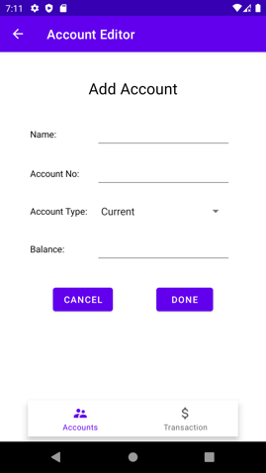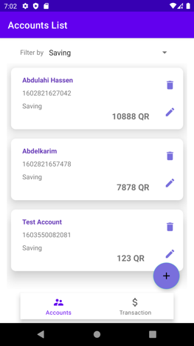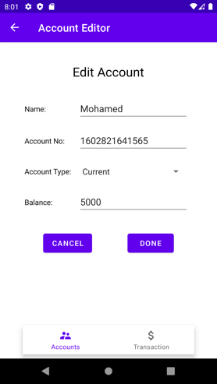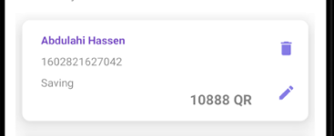

**Figure 1. List and Add Account**

1. Implement the accounts filtering by different account types. When the user, selects the dropdown you should show the three options [all, current and saving].
   1. **All** -> **gets all the accounts** from

<https://employee-bank-app.herokuapp.com/api/accounts>

* 1. **Current** -> gets **current accounts** from

<https://employee-bank-app.herokuapp.com/api/accounts?Type=current>

* 1. **Saving** -> gets saving accounts from

<https://employee-bank-app.herokuapp.com/api/accounts?Type=saving>

|  |  |  |
| --- | --- | --- |
| **All Accounts** | **Filtered by Current** | **Filtered by Saving** |
|  |  |  |

**Figure 2. Filter Account By Type**

Submit the testing sheet as well as the code under “**your_repository/assignments/assignment3**”